**CRM ANALYTICS**

**DATA ANALYTICS MINI PROJECT**

**DOCUMENTATION**

**Purpose and Aim:**

The purpose of this project is to leverage Python for comprehensive analysis and management of customer data within a CRM system.

The aim is to:

* Collect and consolidate customer data from various sources.
* Clean, preprocess, and wrangle the data to ensure accuracy and consistency.
* Utilize machine learning techniques to extract insights and improve CRM strategies.
* Visualize the data to derive meaningful patterns, trends, and customer segments.

**DATA COLLECTION:**

The data has been collected from Kaggle. It was raw data and had lot of inconsistencies so we used different libraries to clean the dataset.

**DATA CLEANING:**

The data was cleaned using pandas and numpy. Unecessary columns were dropped. The outliers were also removed as a process.

**DATA WRANGLING:**

We added a new column profits and did feature engineering on the cleaned data.

**DATA VISUALIZATION:**

We used matplotlib and seaborn to plot various graphs like box plot, pie chart, histogram, scatter plot to show the profits of different country, quantity and the profit, and there are more plots.

**HOW TO RUN :**

* Run all the files on VScode and change the path to the name of the website.

Then we run the server which leads us to the website.

* Ensure proper execution and resolve any errors encountered during the process.
* Monitor the output and review the generated visualizations and data transformations.

**Screenshots of the website:**

Our application was developed using HTML and CSS. The screenshots below vividly depict its visual appearance and layout

Viewing the data:

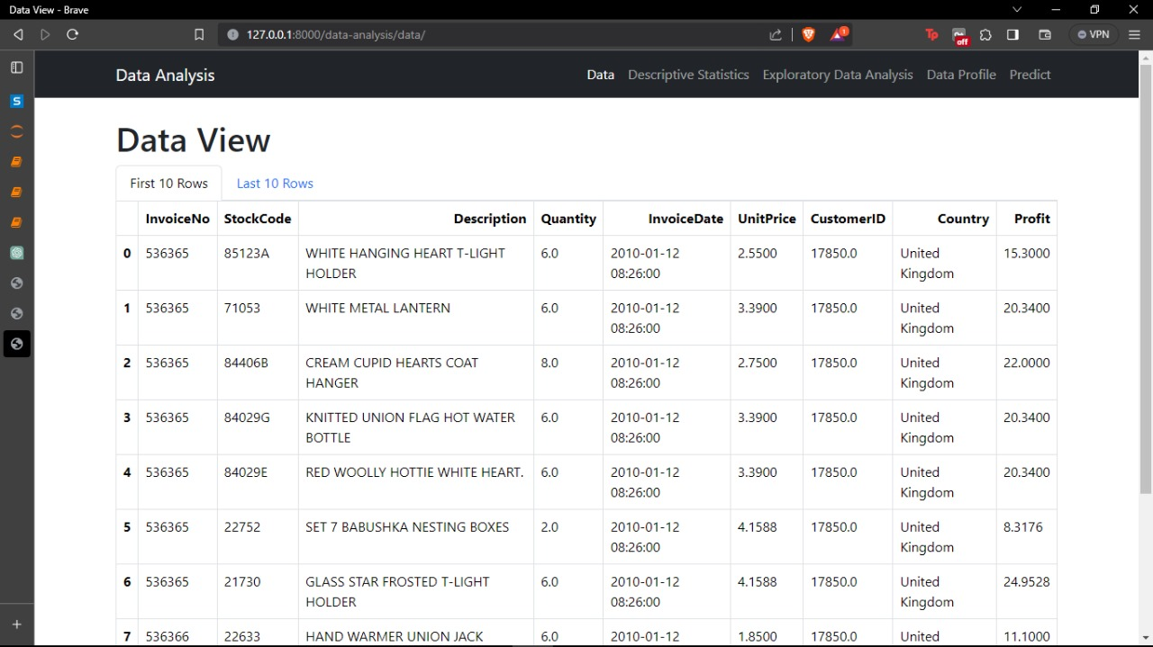

Descriptive Statistics:

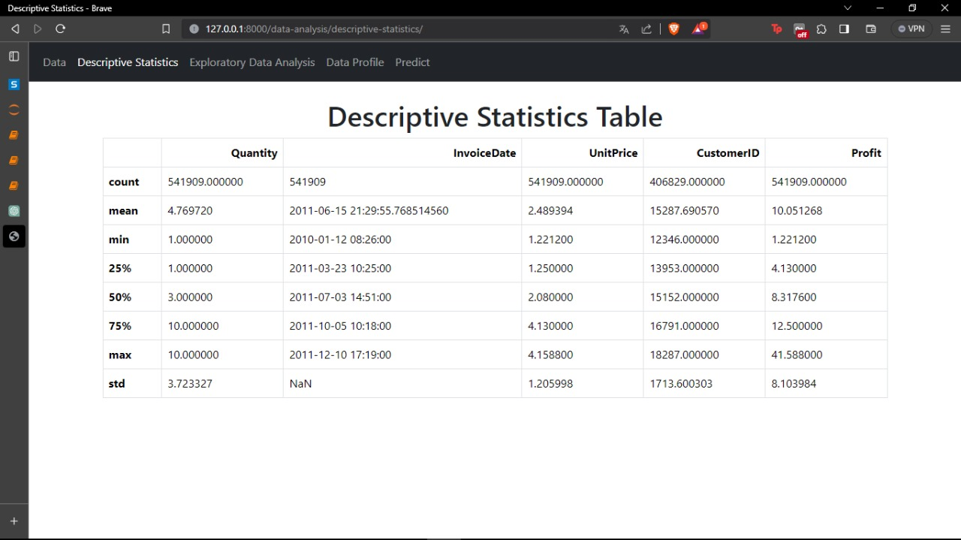

Visualisations:

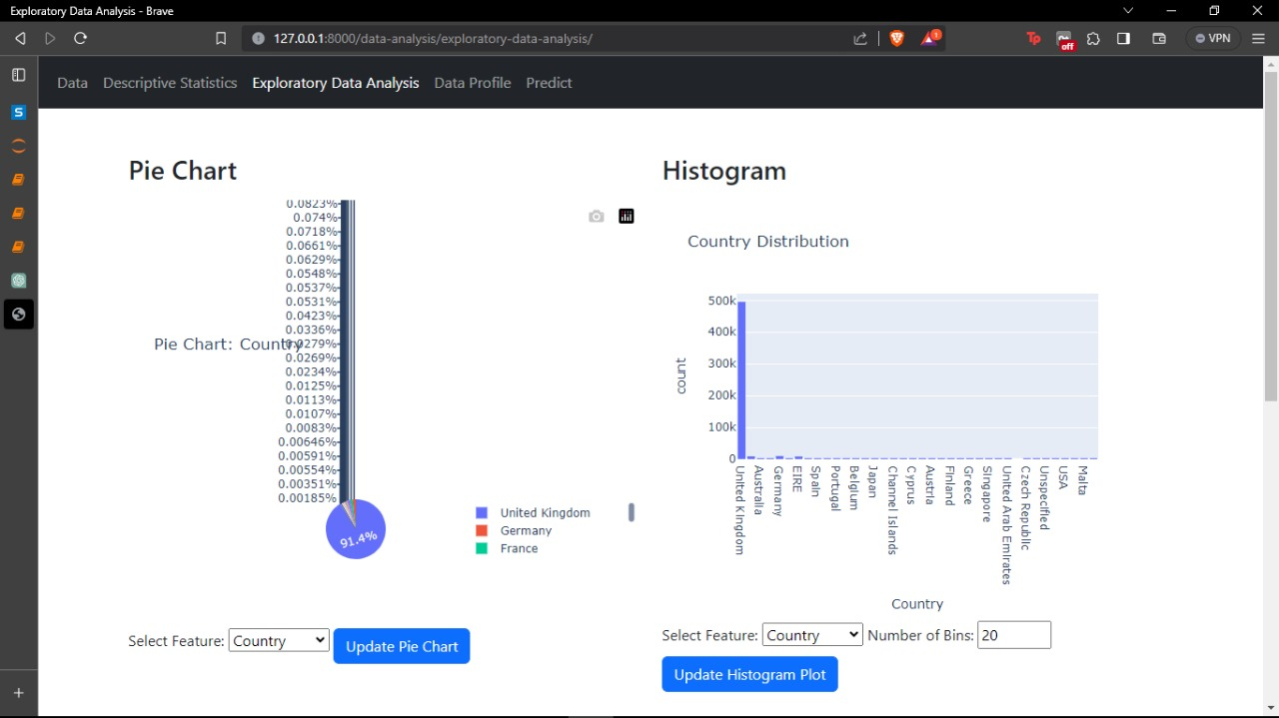

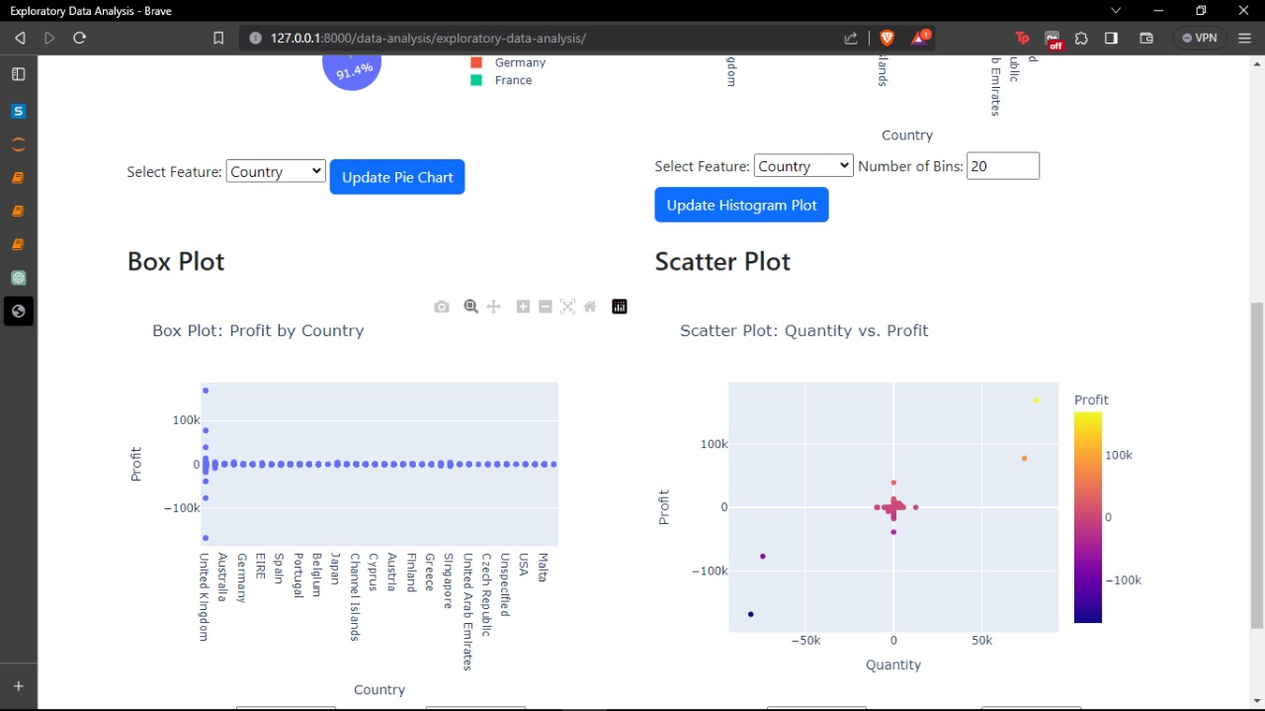

Overview:

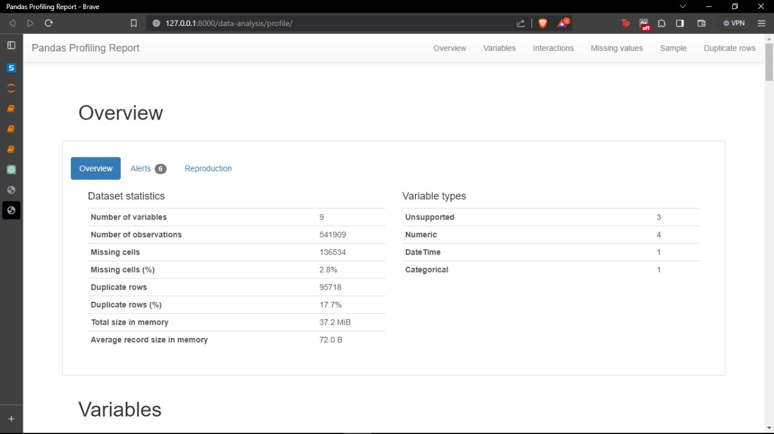

Pandas Profiling Report:

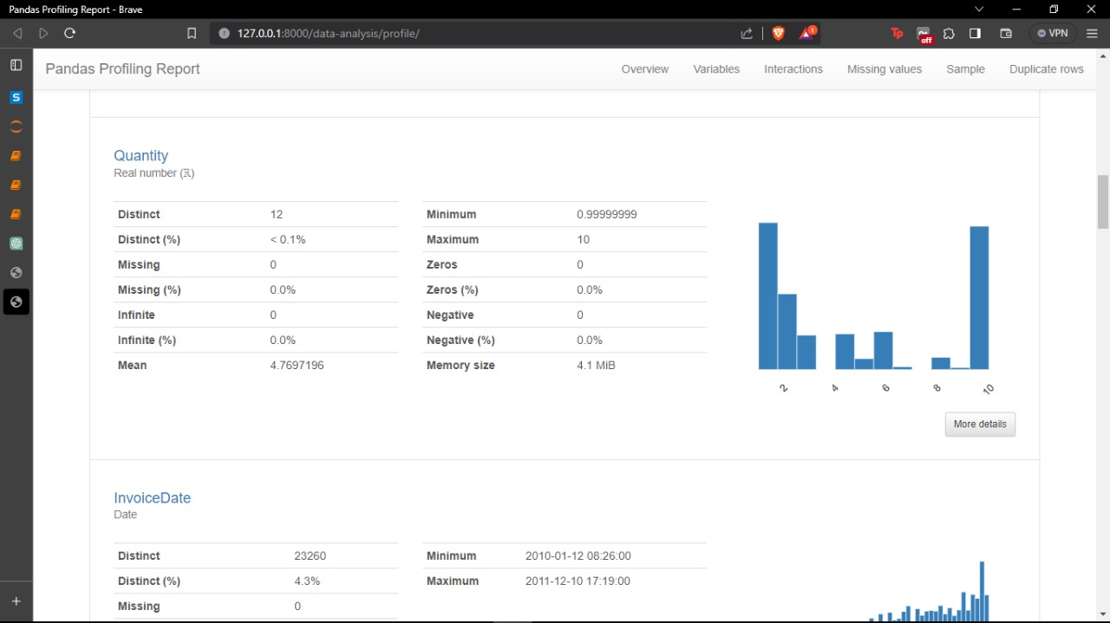

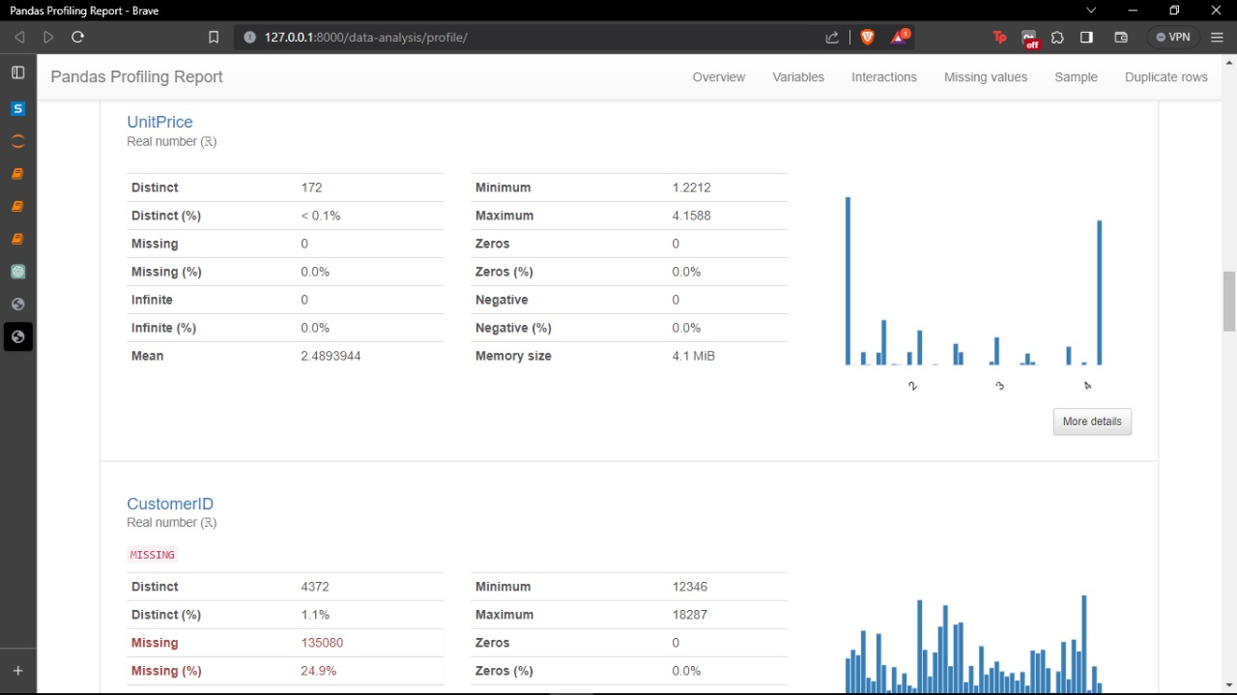

Interaction between different variables:

